**CURRICULUM VITAE**

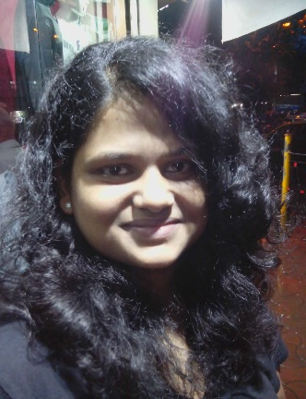

**Kalpita Ramesh Bhor**

9/14, Vishwas Niwas,Acharya

Donde Marg

Parel Mumbai-400012

Phone No. 8286956196, 8898666946

Email: kalpitabhor@gmail.com

**Career Objective**

I want to associated myself with an organization, which will help to bring be best out of me, which will provide me platform to apply my skillset and give me opportunities so that symbolically for me and to the organization to give profit.

**Educational Qualifications**

|  |  |  |  |
| --- | --- | --- | --- |
| **Degree/ Examination** | **University/Board** | **Year of passing** | **Class** |
| Master Of Commerce (Management) | Mumbai University | 2013 | Second |
| Bachelor Of Commerce | T.K.Tope College (Mumbai University) | 2010 | Second |
| Higher Secondary School (H.S.C) | Maharshi Dayanand College (Mumbai University) | 2007 | First |
| Secondary School Certificate (S.S.C) | R.M.Bhatt High School (Mumbai University) | 2005 | Pass |

**Additional Qualification**

➢Diploma in office Automation & Graphic’s

➢     Diploma in Travel Agency Operation & CRS (Amadeus)

**Experiences**

8 Months Working as a Administrative Executive in Pinak Company.

**Job Profile**

* Conserves executive's time by reading, researching, and routing correspondence; drafting letters and documents; collecting and analyzing information; initiating telecommunications.
* Maintains executive's appointment schedule by planning and scheduling meetings, conferences, teleconferences, and travel.
* Represents the executive by attending meetings in the executive's absence; speaking for the executive.
* Welcomes guests and customers by greeting them, in person or on the telephone; answering or directing inquiries.
* Maintains customer confidence and protects operations by keeping information confidential.
* Completes projects by assigning work to clerical staff; following up on results.
* Prepares reports by collecting and analyzing information.
* Secures information by completing data base backups.
* Provides historical reference by developing and utilizing filing and retrieval systems; recording meeting discussions.

**Personal Particulars**

Father’s Name             Ramesh Bhor

Permanent Address 9/14, Vishwas Niwas,Acharya Donde Marg.

Date of BirthJuly 7, 1986

Gender                         Female

Languages Known       English, Marathi, Hindi, Gujarati

Nationality                   Indian

Marital Status               Single

Hobbies Reading Books & Listening Songs

Skills Excellent Communication, Good Learner, Hunger for Growth

Here by I declare that all the information above is true as per my knowledge.

(Kalpita Bhor)